REAL First Aid Ltd

EXAMINATIONS POLICY

8th March 2023

Examination Regulations
- Students will not normally be permitted to enter the examination room after the first 30 minutes of the examination (including any period of reading time as appropriate) have elapsed.
- For examinations of up to and including one and a half hours in duration, no student may leave the examination during the first 30 minutes or the last 15 minutes. For examinations over one and a half hours in duration, no student may leave the examination during the first 30 minutes or the last 30 minutes.
- Strict silence must be observed at all times in the examination room.
- Students must not communicate with each other during the examination.
- All personal belongings, briefcases, bags, books, notes etc. must be placed in a designated area identified by the invigilator. Students taking open book examinations may only use books, notes, etc. specified by the examiner. Students requiring further equipment from a bag or briefcase after the commencement of the examination must ask an invigilator to obtain it for them.
- Students are requested to switch off mobile phones and place them with their belongings in the designated area. If a candidate is found in possession of their mobile phone during the examination they will be deemed to be contravening the examination regulations.
- English and foreign language dictionaries are permitted in examinations. Any unauthorised material discovered inside dictionaries will be confiscated and candidates will be deemed to be in breach of examination regulations. Electronic dictionaries are not permitted in examinations.
- After question papers have been distributed, students may not consult the question papers until instructed to do so.
- Students found copying, communicating with another student, or using any unauthorised materials may be expelled from the room.
- Any activity which results in malpractice or suspicion of malpractice will be followed up in line with our Malpractice Policy
- Should any student have to leave the examination room for personal reasons, they must be accompanied by an invigilator.
- Any candidate who leaves the room unattended will not be allowed to return to the room.
- Any candidate who wishes to leave the examination early must have their script collected by the invigilator before they leave their desk.
- In the event of illness, should the candidate feel unable to continue with the examination, the student should remain seated and raise their hand to attract the attention of an invigilator.
- If the fire alarm sounds during the examination, students must follow the instructions of the invigilator. Students must leave the room in silence and must not take any papers or material from the room and must adhere to examination regulations. Students must not re-enter the room before they are instructed to do so.
- Students must ensure by the end of the examination that their work is clearly labelled with their name and date and that additional sheets have been securely attached to the answer book and that their details have been entered on each additional sheet.
- When time is called at the end of the examination, students must stop writing immediately.
- Students must remain seated until all scripts have been collected and counted and the invigilator gives the signal to leave the room.
- Declaration

On behalf of Real First Aid Ltd we, the undersigned, will oversee the implementation of the Examinations Policy and take all necessary steps to ensure it is adhered to.
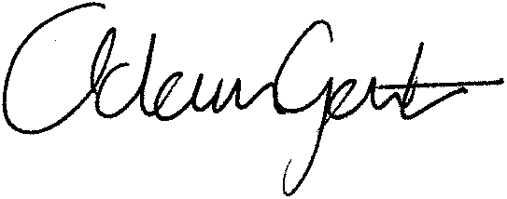
Signed:

(n.b. One of the signatories should be the Director)

Name: |  | Adam Gent
Position within the Company: |  | Director
Date: |  | 8th March 2023

